The application was developed during the tenure of my internship from 19 March 2018 to 3 August 2018 at Singapore-MIT Alliance for Research and Technology (SMART). The program was written in Java mainly due to its software portability, which enables its execution in all operating systems as long as a Java Runtime Environment (JRE) is currently installed on the individual system. It was developed specifically to accommodate the processing and visualisation of WorldView-2 and WorldView-3 .tif images, which are distributed by DigitalGlobe.

The original program features included having the interface for selecting relevant .tif raster images for visualisation, calculating, cropping and displaying portions of the raster layer with reference to the screen size for faster loading and panning of the image, as well as generating raster pyramids of the original .tif raster to eliminate the loss of data from resizing the image when changing zoom depth.

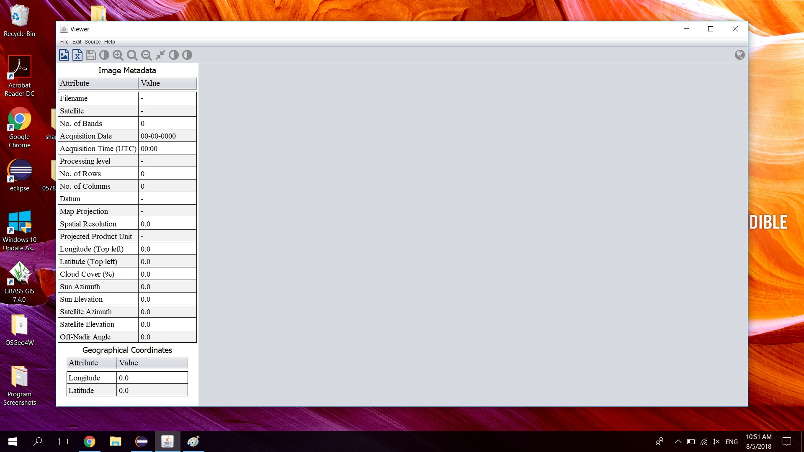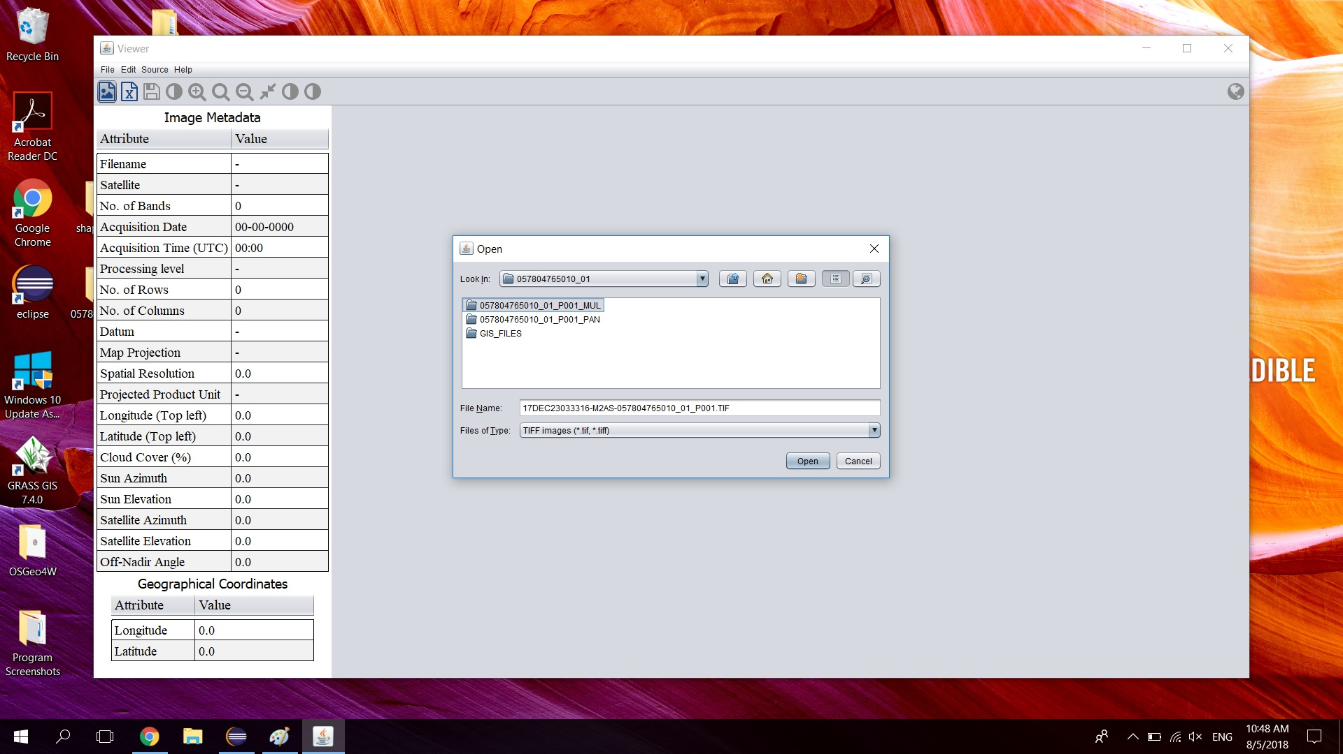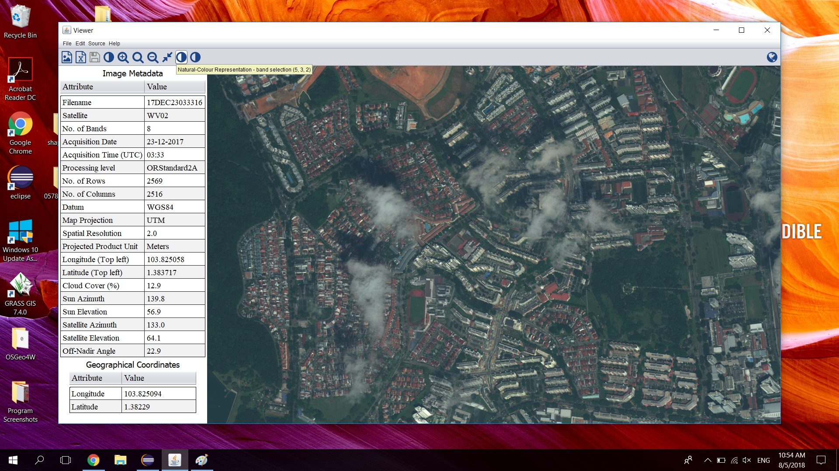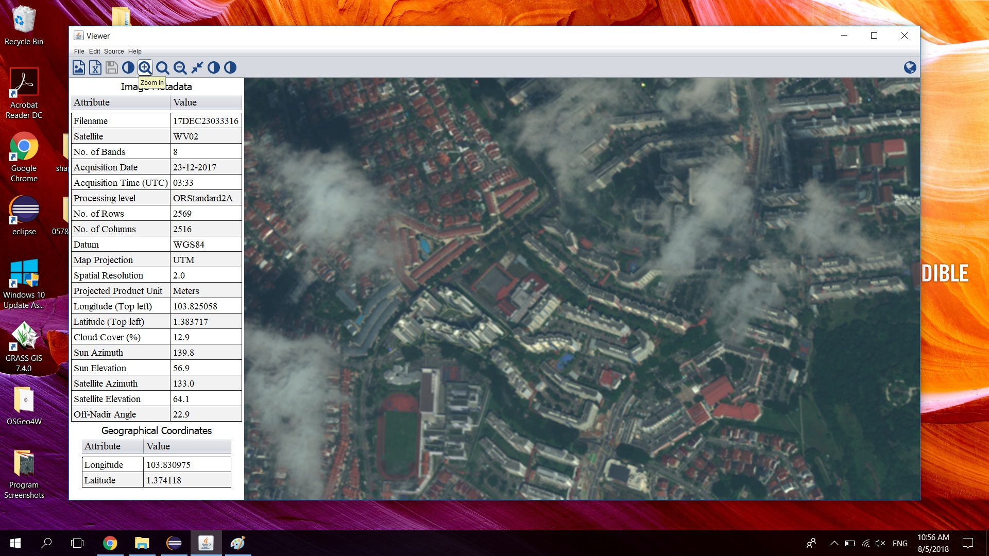

*The 4 images above show some of the features and design of the old interface.*

Version 2.0 of the application involved having the program automatically import and process the respective .xml document of the .tif raster, extract and display the data of interest (spatial resolution, acquisition date and time, sun azimuth and elevation etc.) in a column format (seen from the images above). The exact geographical coordinates of where the mouse is currently hovering over is also displayed in a separate segment in the left column through the use of extracting the geo-coordinates of the 4 corners and applying bilinear interpolation. In addition, I also included the function to manually select the .xml file when encountering errors in importing automatically.

The next development involved the visualisation of different bands of specific wavelengths corresponding to its radiance in a multispectral raster image. A few presets were created (such as bands 5,3,2 for natural-colour representation, or bands 7,5,4 for pseudo-colour representation) for the ease of access, including the function to manually select bands of interest, change brightness and trim. Furthermore, a thumbnail feature was also developed to assist the user in panning, as well as in determining the exact location of the image shown on the screen with respect to the whole image.

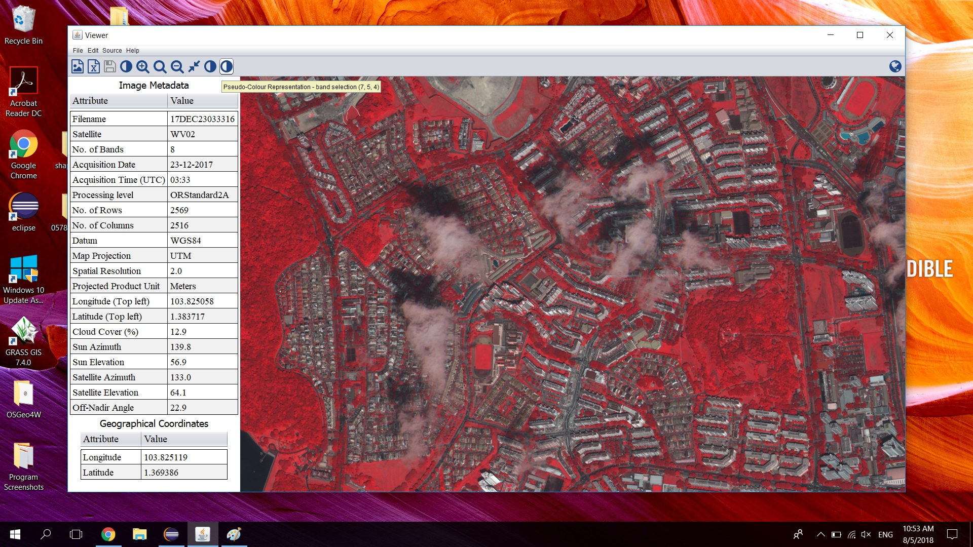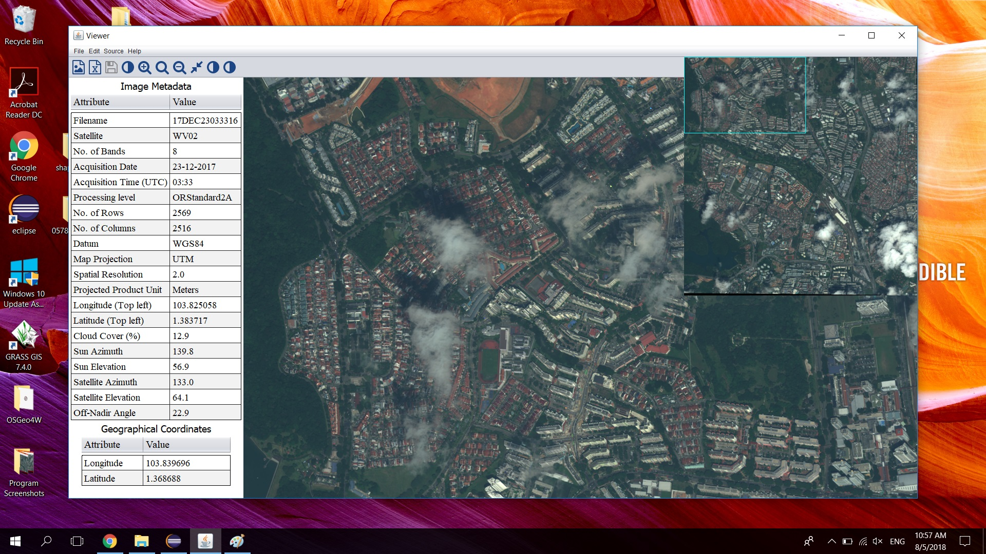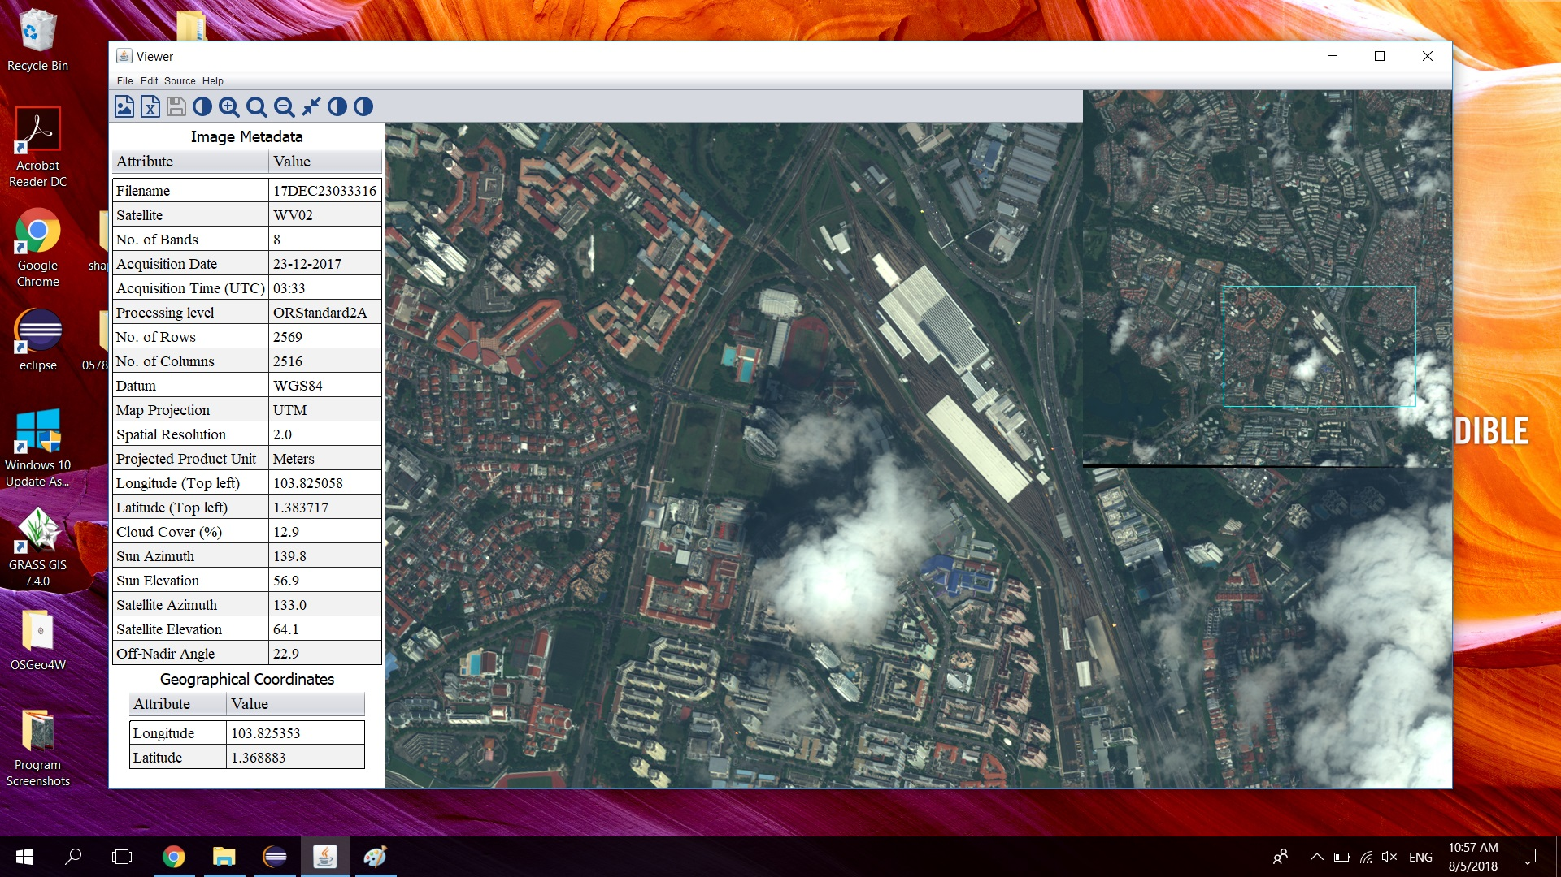

*The 3 images above demonstrate the features described.*

There was an overhaul of the user interface, I re-designed it to make it more aesthetically pleasing, removing the left column and creating a button with a pop-up window to display the relevant data in the .xml file in a table format. The code for the small window displaying current long-lat was also rewritten such that it will shift its position with reference to mouse movement.

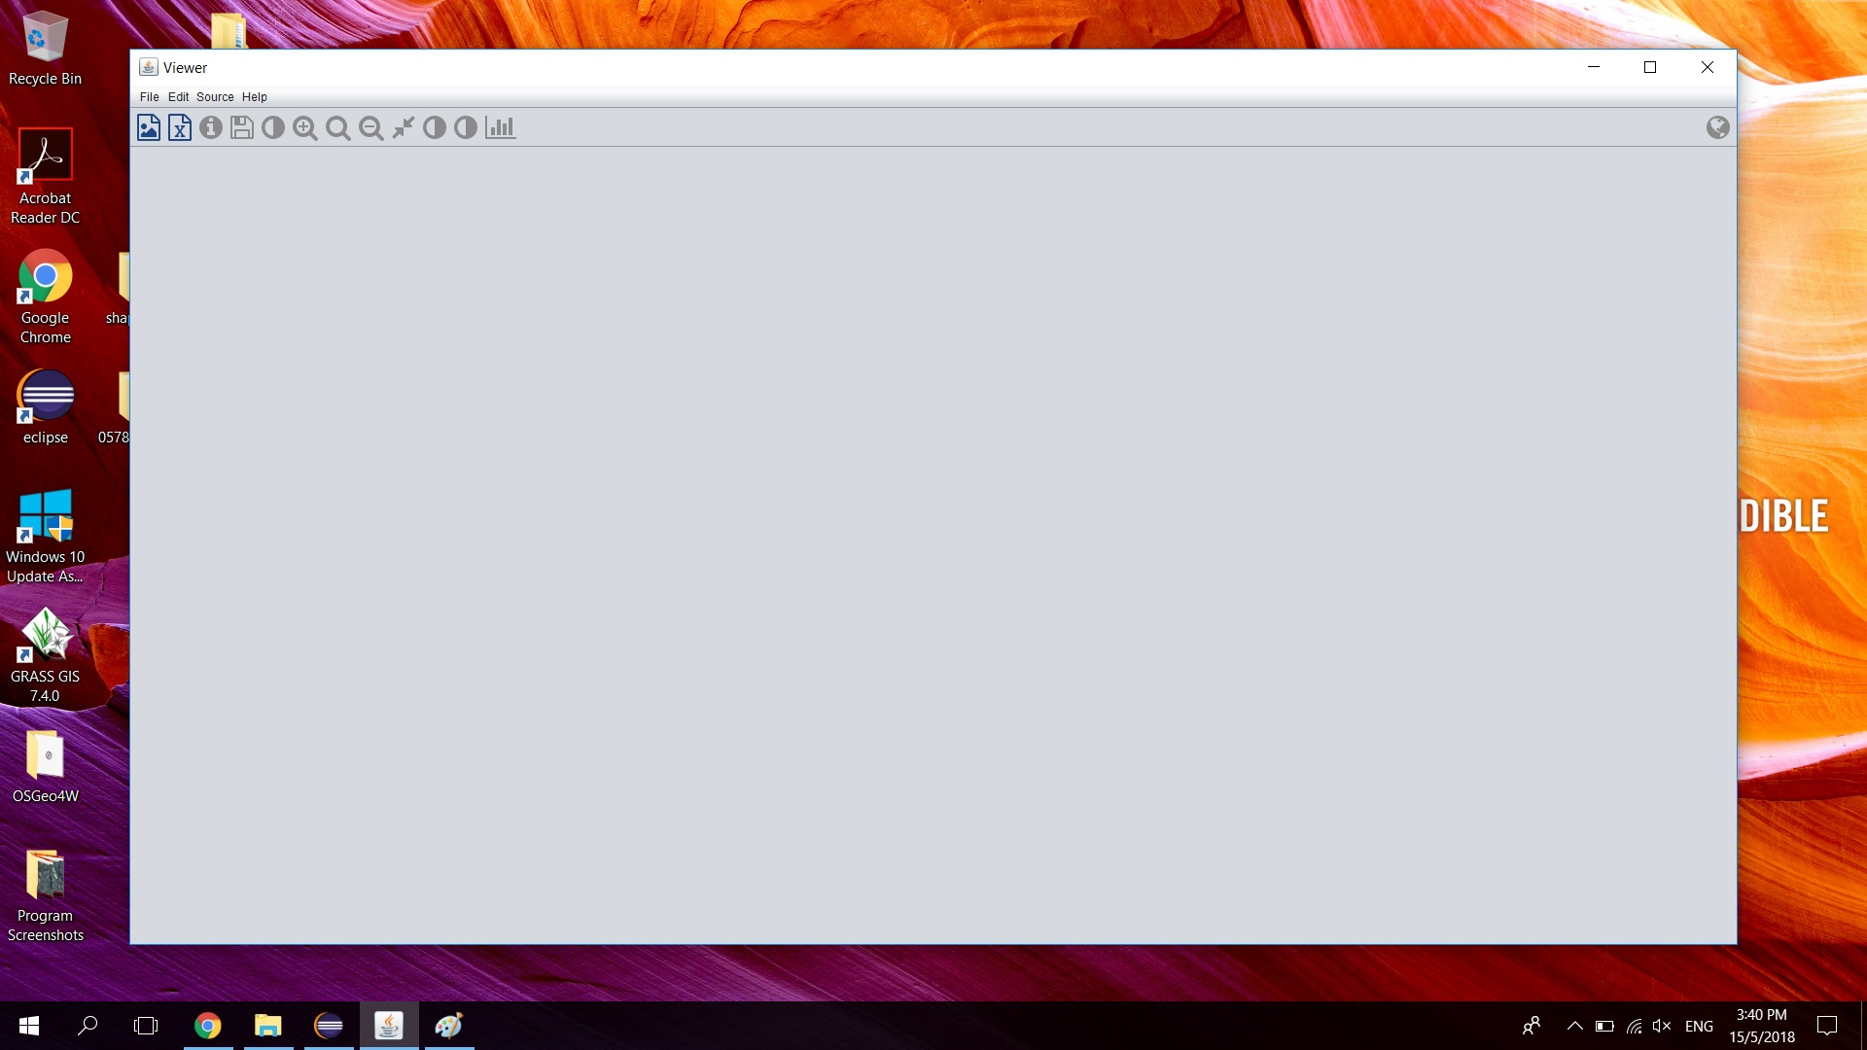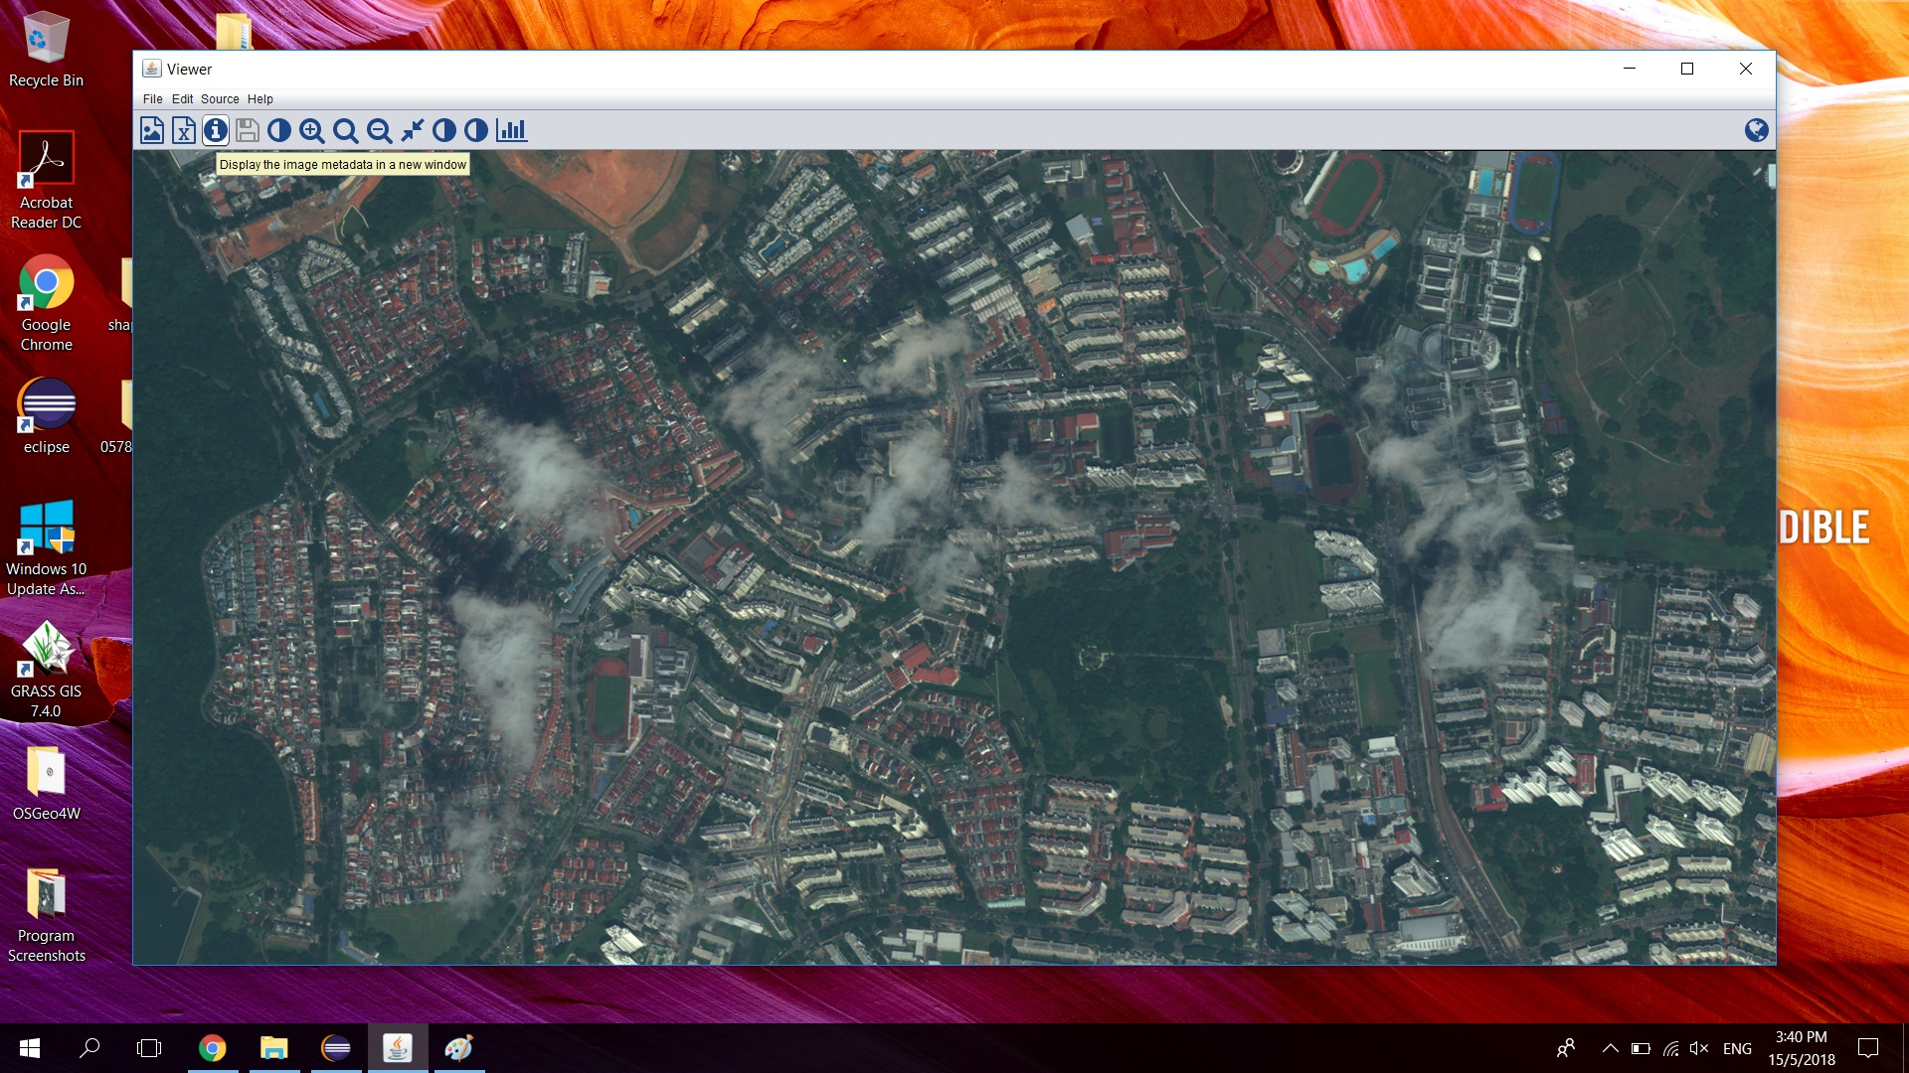*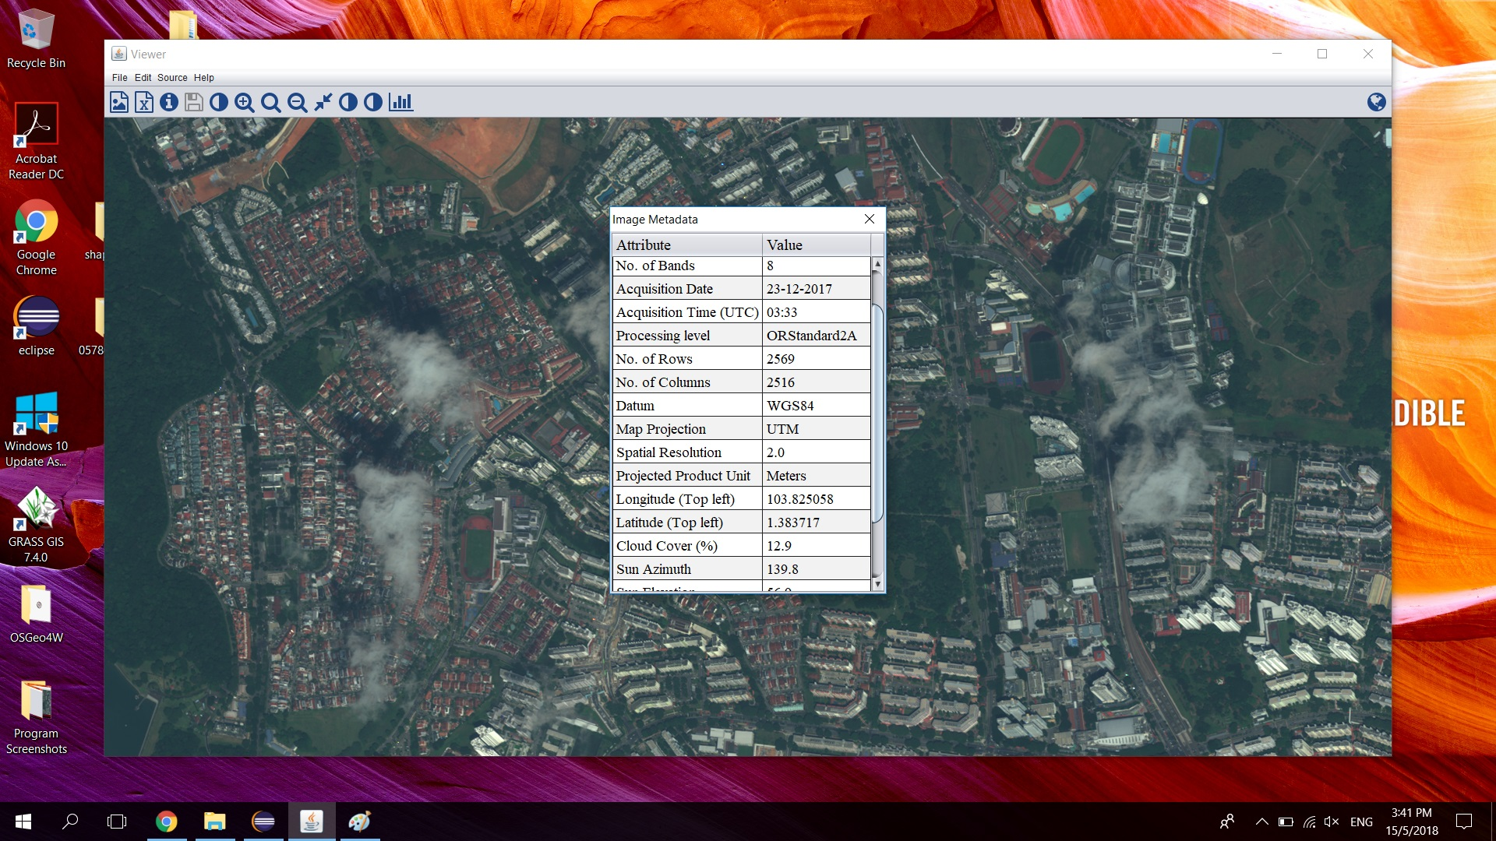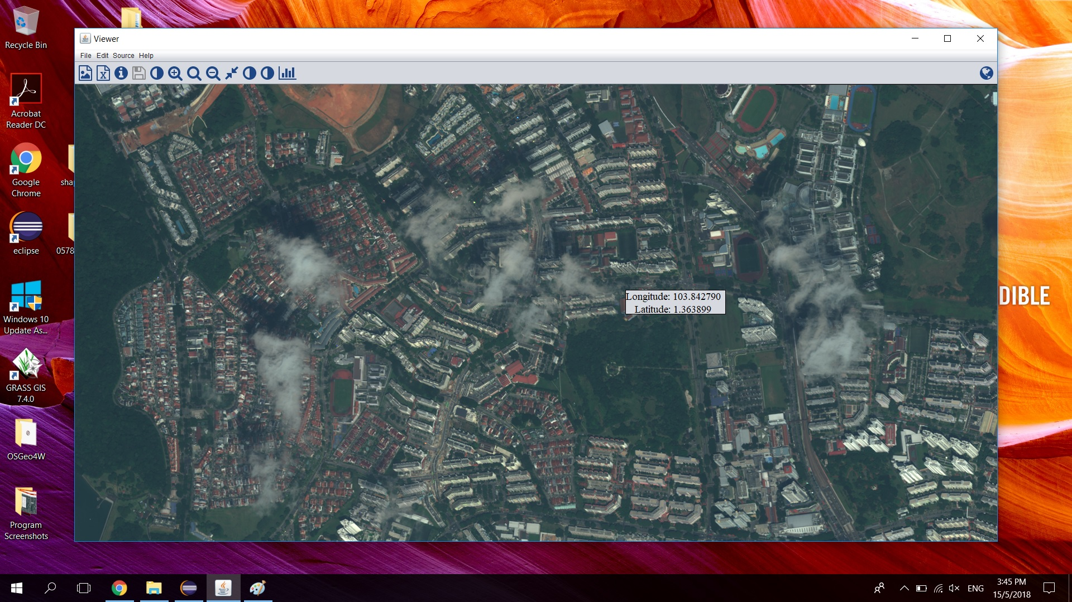*

*The above images show the new interface, the button to display information extracted from the .xml file, as well as long-lat tracking of the mouse position.*

The next update involved visualising of the Normalized Difference Vegetation Index (NDVI), mainly through extracting every band radiance of each pixel, calculating and storing the ratio into an array and visualising this array of ratios through a monochromatic raster layer, where the brighter/ whiter the pixel, the higher the likelihood of the pixel containing vegetation. To reduce the runtime of the function calculating/ displaying the NDVI, the ratio for the whole raster will be calculated once and stored temporarily, with only the portion corresponding to the screen size being processed and visualised. Subsequent clicks of the button will bring up this raster instead of recalculating a brand new one, however the whole process will have to be restarted for a new raster image or once the program has closed. Furthermore, I created a function to display the radiance of all 8 bands of the pixel the mouse is currently hovering over in a bar-chart format, which changes dynamically depending on mouse movement.

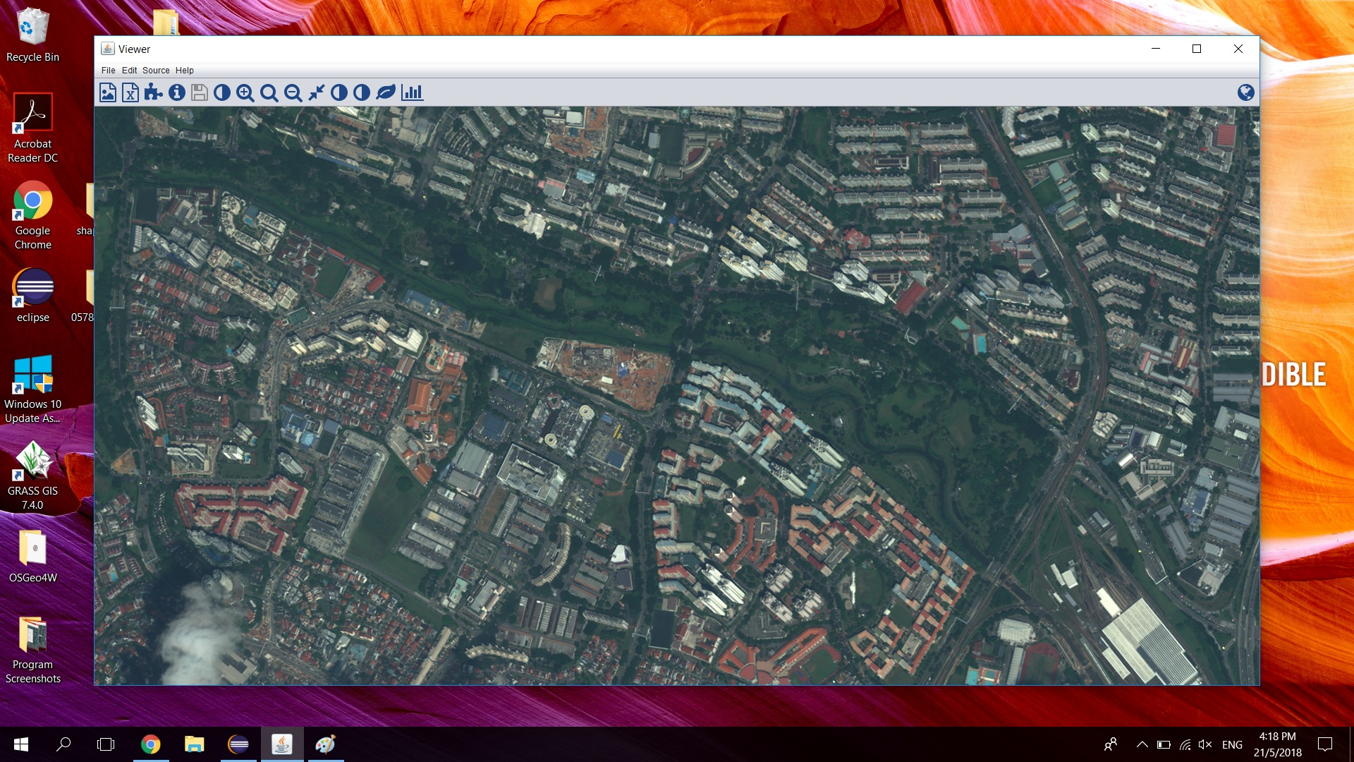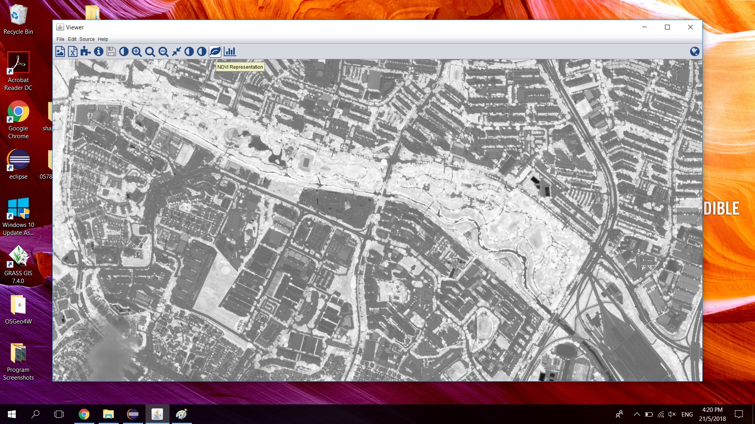

*Above images showing the before-and-after of the NDVI function.*

The next development involved importing and processing of polygon vectors .shp files and visualising them on the raster layer. Together with the development came the function to show/ hide all polygon vectors, and the ability to view the data from the .shp files in another tab by clicking the same information button to view the .xml file. Mouse listeners were also written to enable the user to create their own polygons on mouse click to create the vertices and the “ENTER” button to generate the polygon. A save feature was also implemented as a means to save user-created polygons in a .shp file.

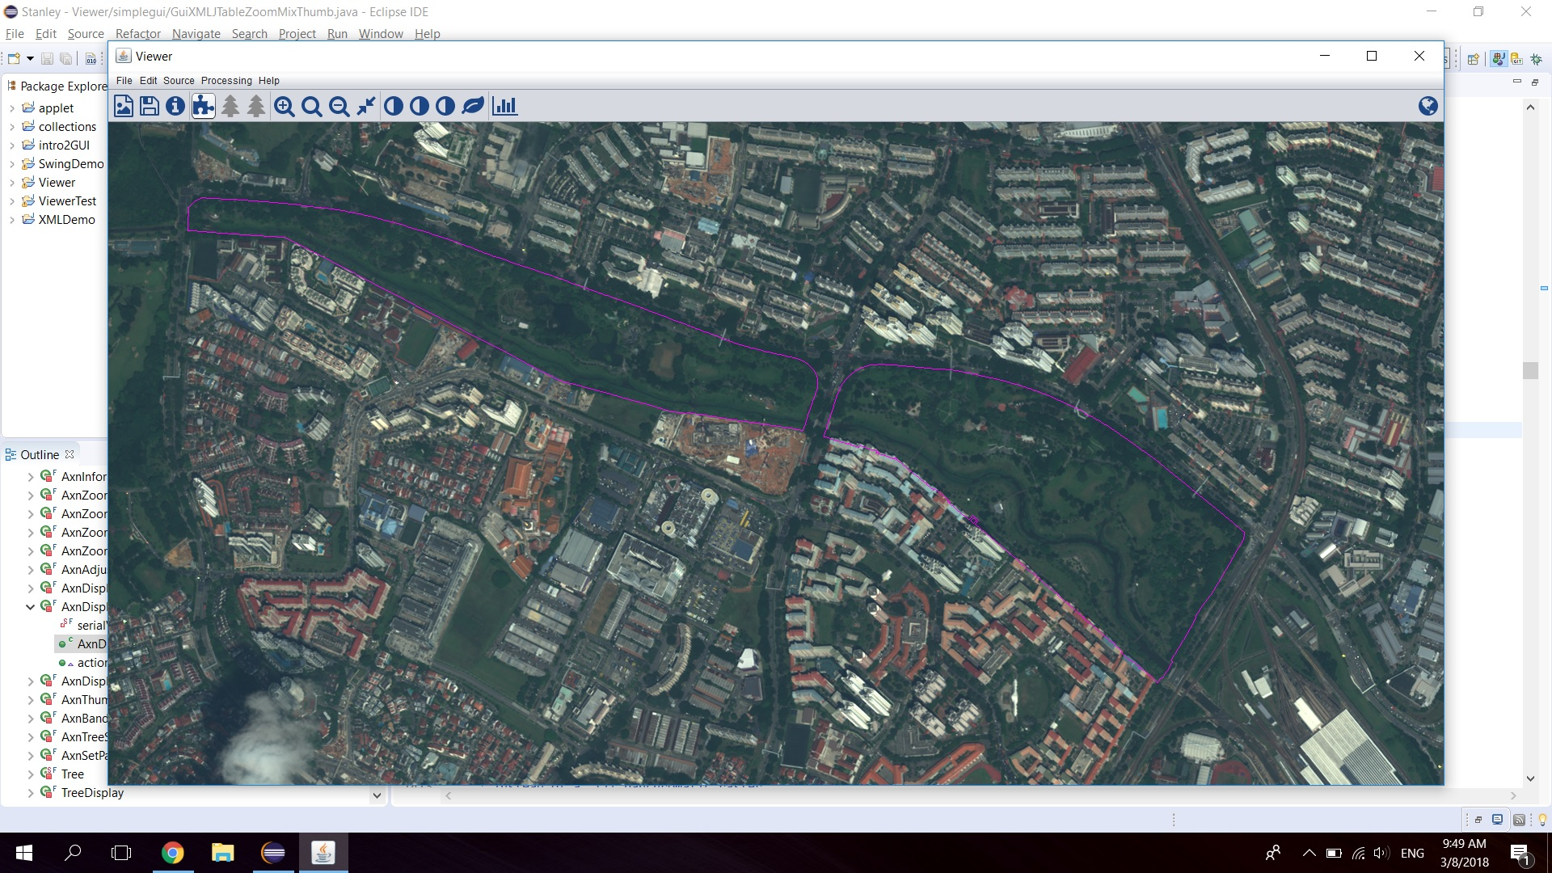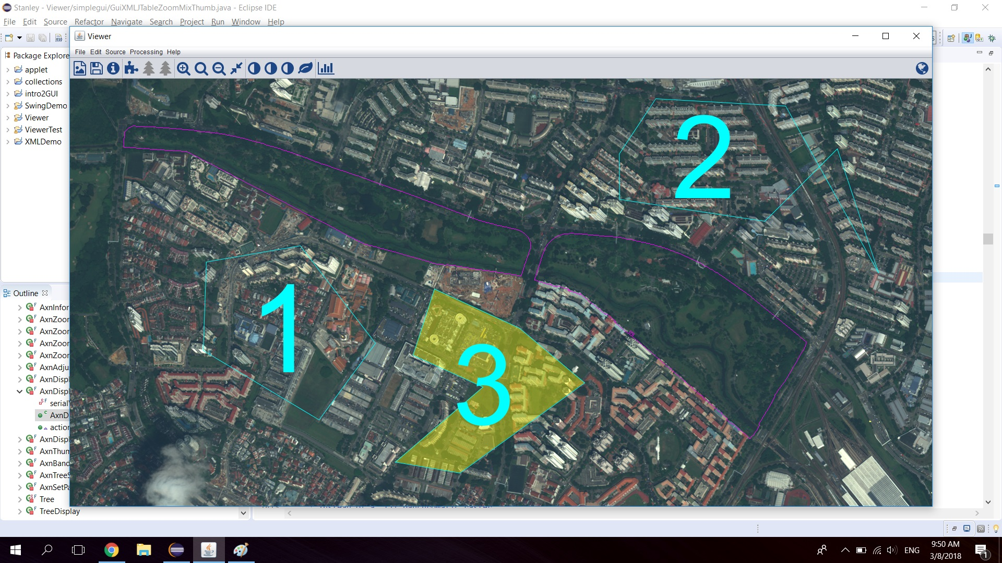

*Above images showing the imported .shp file with a purple outline as well as user-created polygons with the light-blue outline labelled as “1”,”2” and “3”. The user-created polygon that is currently selected will be highlighted in yellow.*

Next, I moved towards visualisation of trees as point vector .shp files. This was only possible due to the fact that NParks had a whole database containing every tree in the park stored as .shp files, and I could just import the file instead of manually identifying trees in the satellite image. Arbitrary colours were assigned to each individual tree, as a means to signify their health. Yellow means no change (healthy), green means improvement (healthy), red means deteriorating (unhealthy), while white means that the trees have no value assigned to them currently.

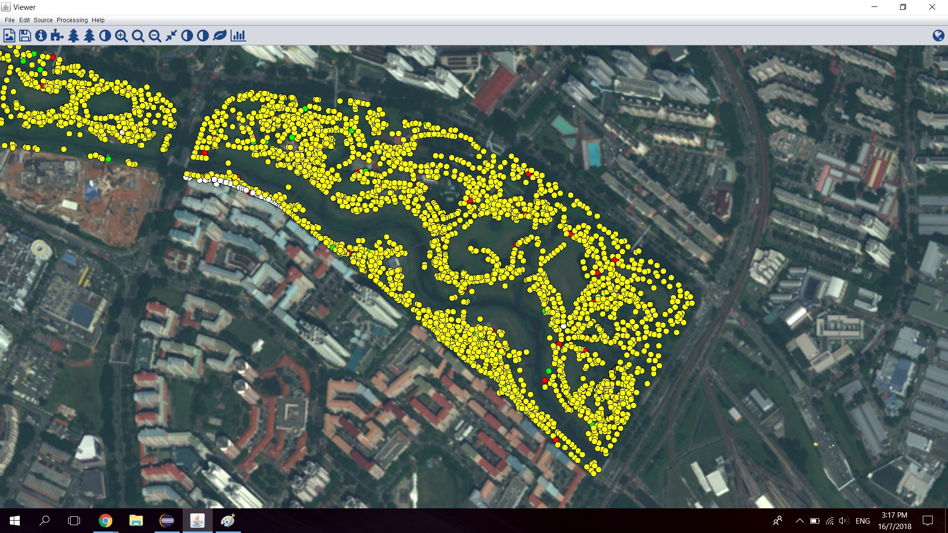

*Image showing the visualisation of all tree species in Bishan Park 1.*

Furthermore, I created features for the user to choose which tree species to display, singular as well as multiple species, show/hide unselected tree species, select & view specific tree info on mouse click, as well as to calculate a histogram of the tree species with respect to the population of trees in the whole park, which can be viewed from the same information button as above by selecting the “tree species” tab.

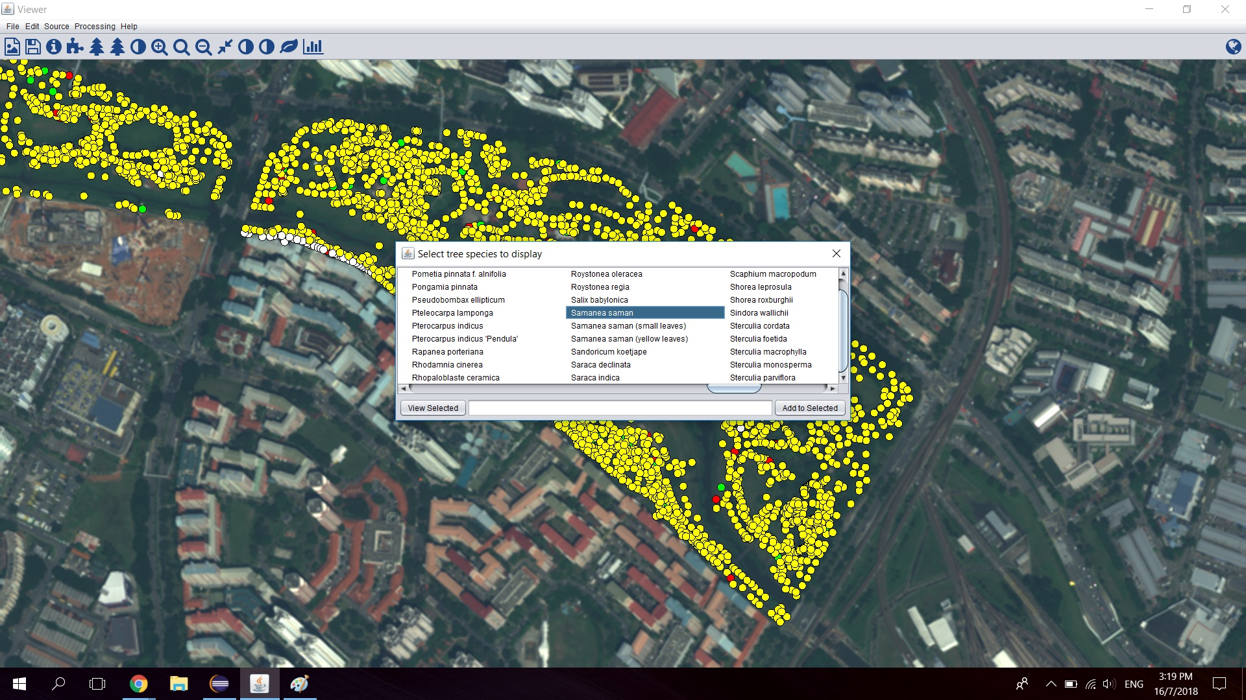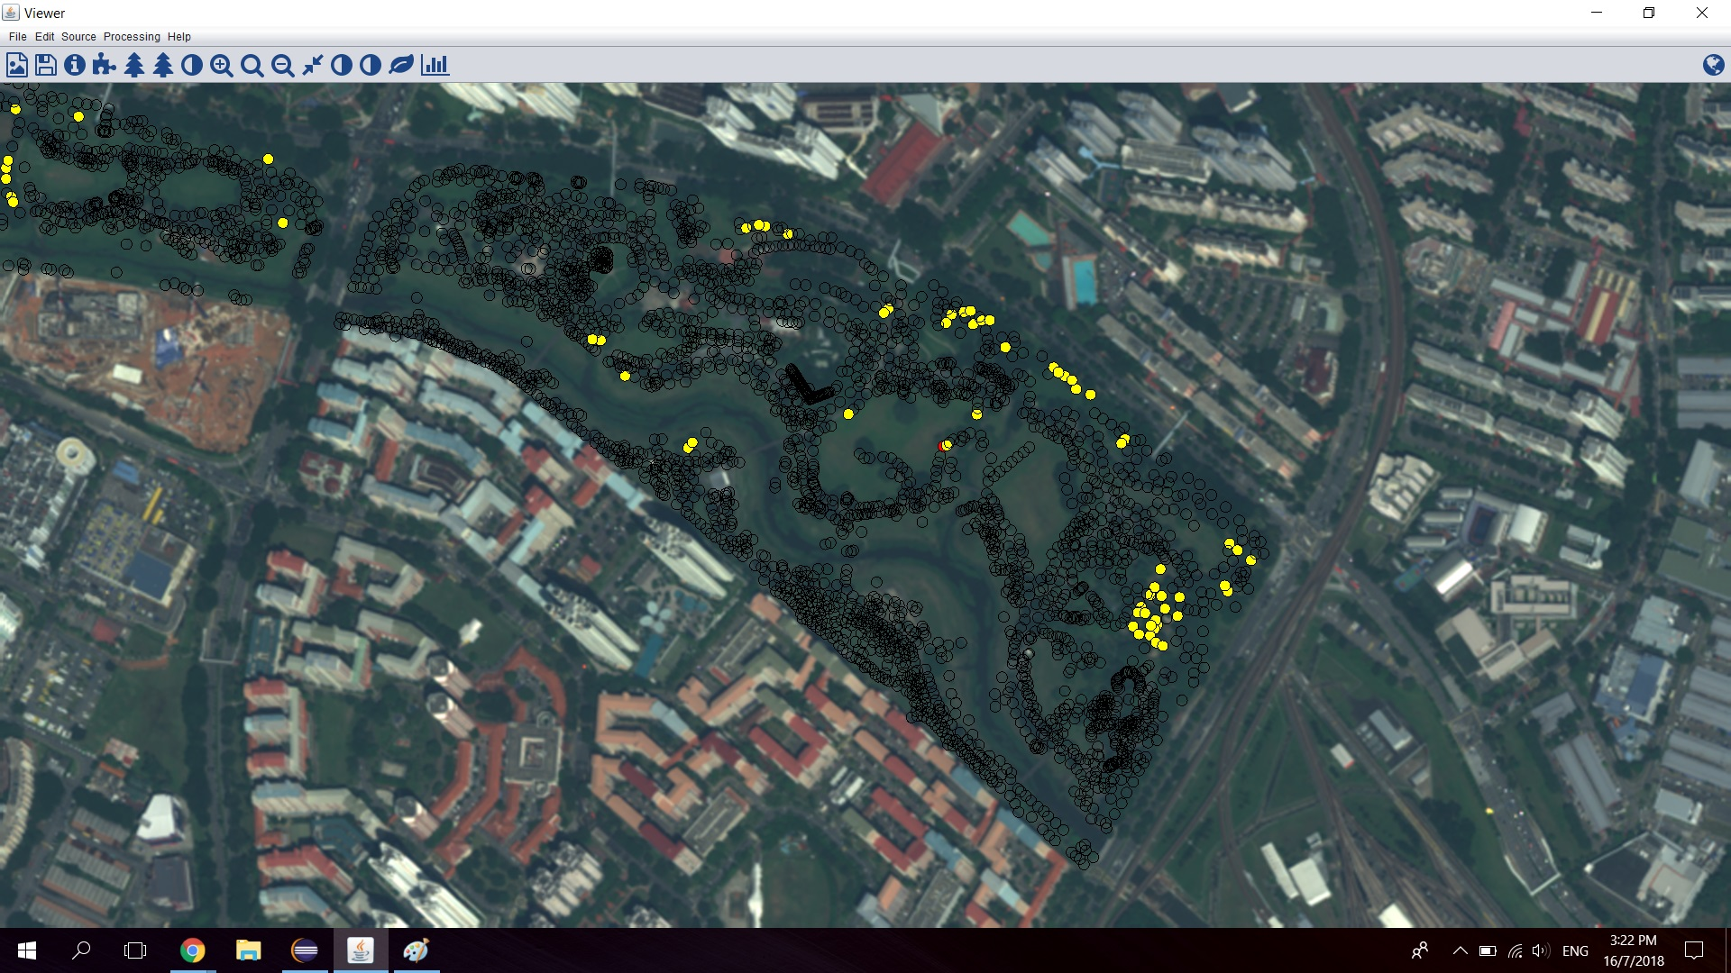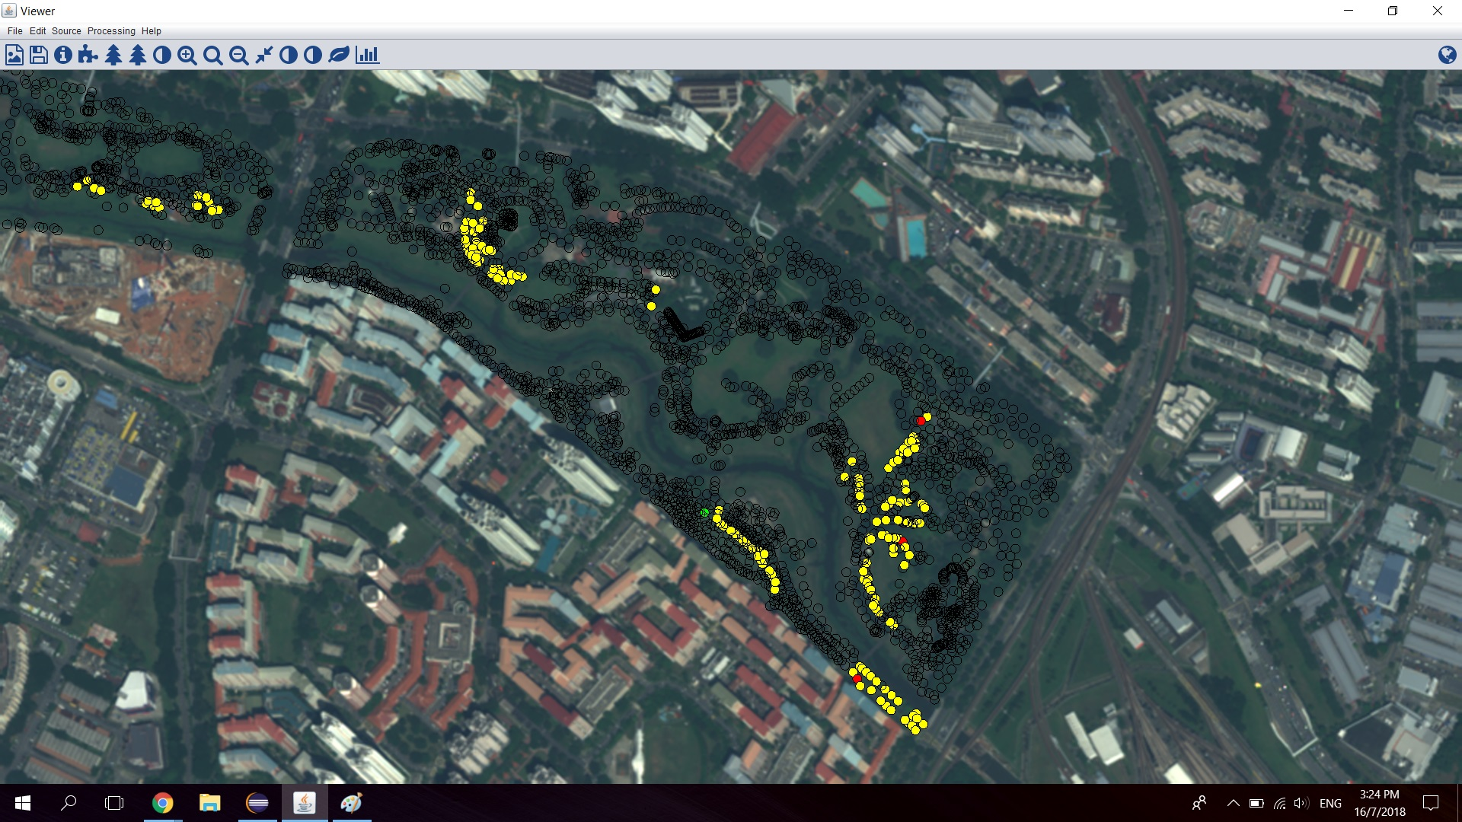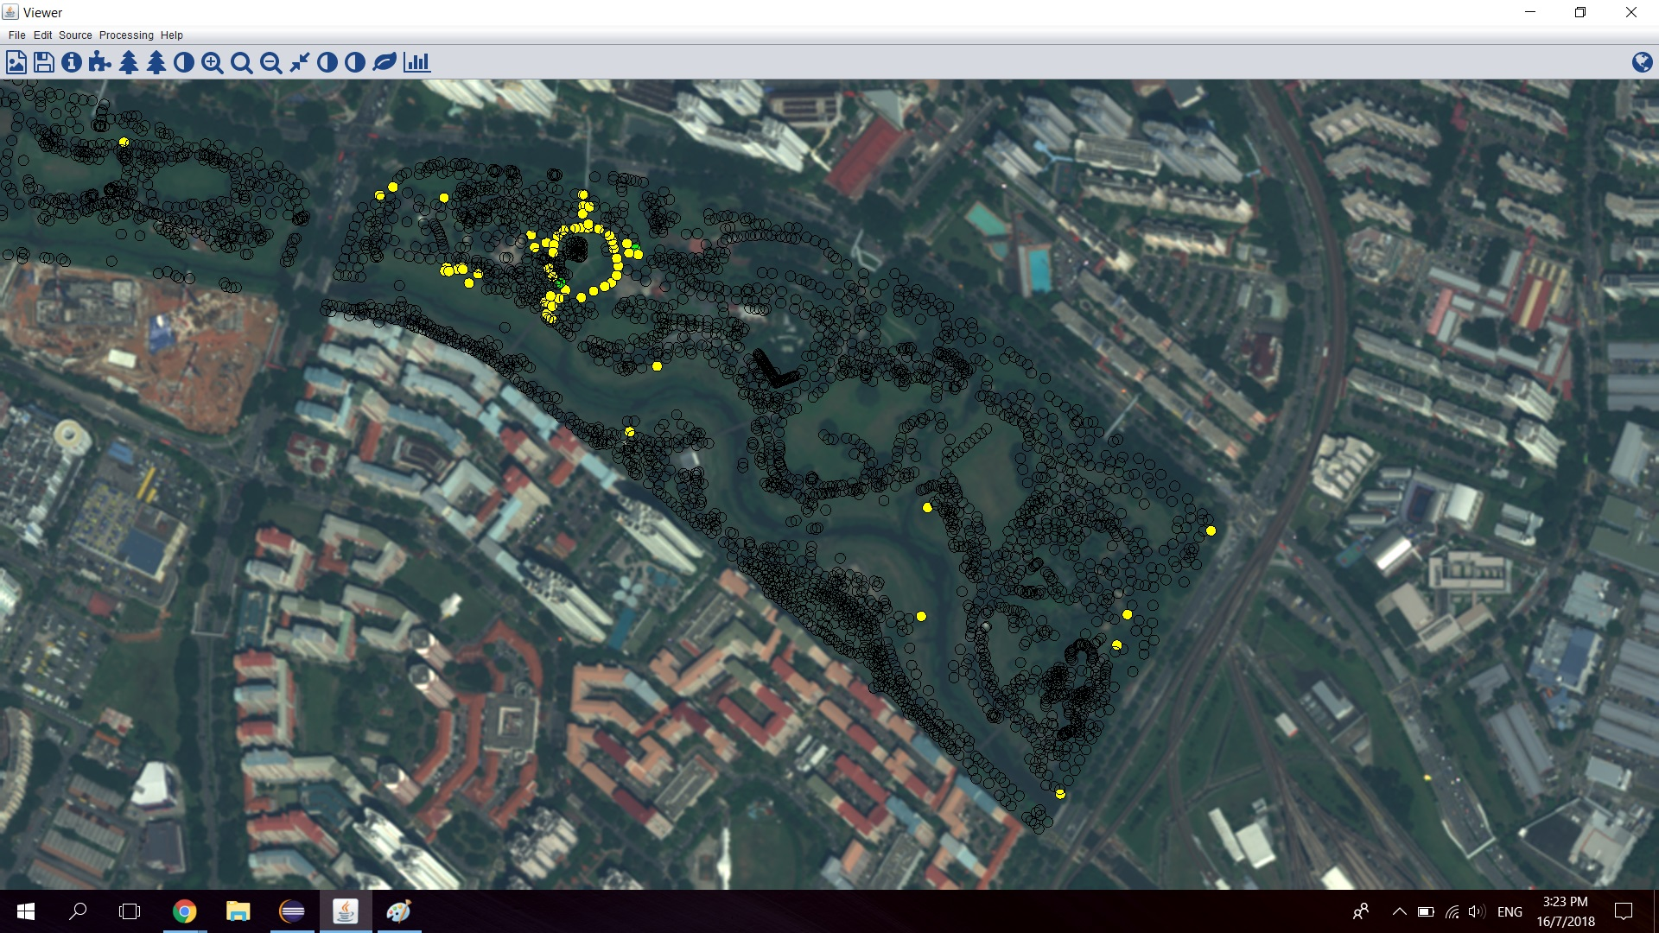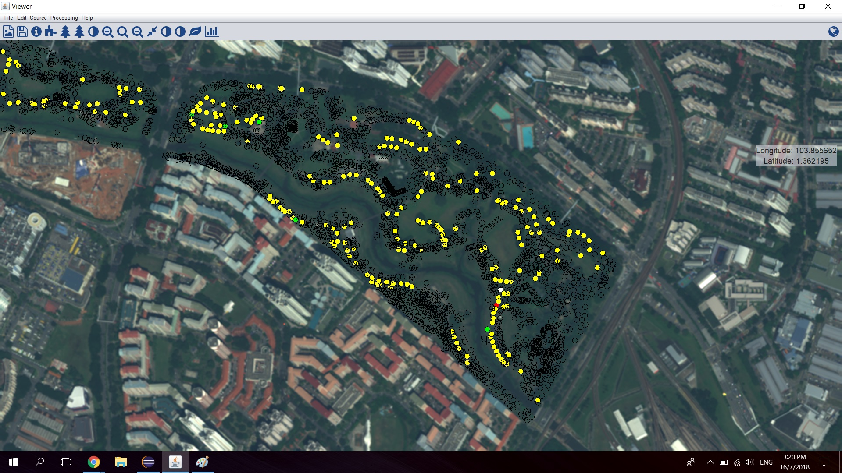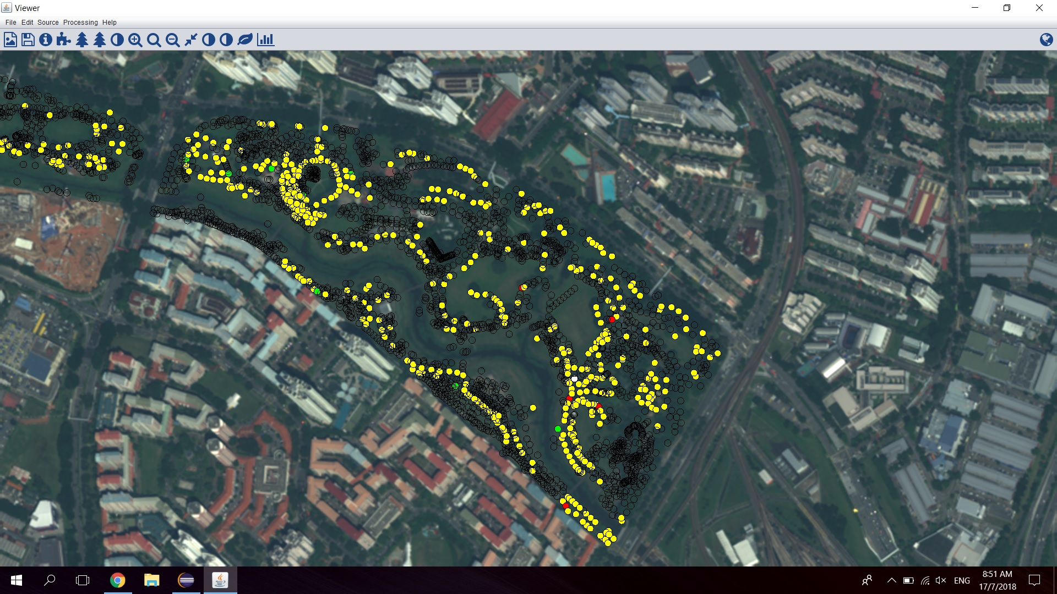

*The interface when choosing individual tree species to display (top left), selecting only Khaya Senegalensis (top right), selecting only Tabebuia Rosea (middle left), selecting only Peltophorum Pterocarpum (middle right), selecting only Samanea Saman (bottom left) and selecting all 4 species (bottom right).*

Lastly, since the project only involves specific regions in Singapore, namely Bishan Park, West Coast Park and Novena Rose Park, I developed the feature to set the view over these specific areas by getting specific geographic coordinates of these locations and setting the image crop over them, provided they are within the image boundary.